**Tutorial 01**

* First you make a 3D cube object and scale it as it will look like a ground
* Then make two other 3D objects and name it as TopStomp and BottomStomp.
* Place it accordingly, the Sphere objects will move in between these two Stomps.
* Then create Sphere object and add a Rigidbody into it. (Add Component > Rigidbody )
* Add a C Sharp script to the Sphere Object and name it as Movement. And now open the script from MonoDevelop or Visual Studio.

*Now the Coding part….*

When you open the Script, you will something like this

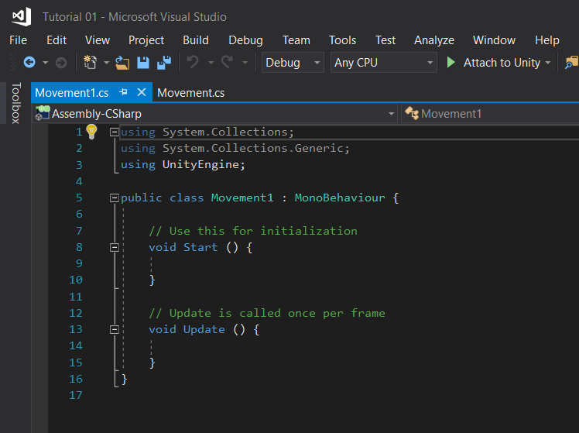

You can delete the void Update function because we won’t be using it.

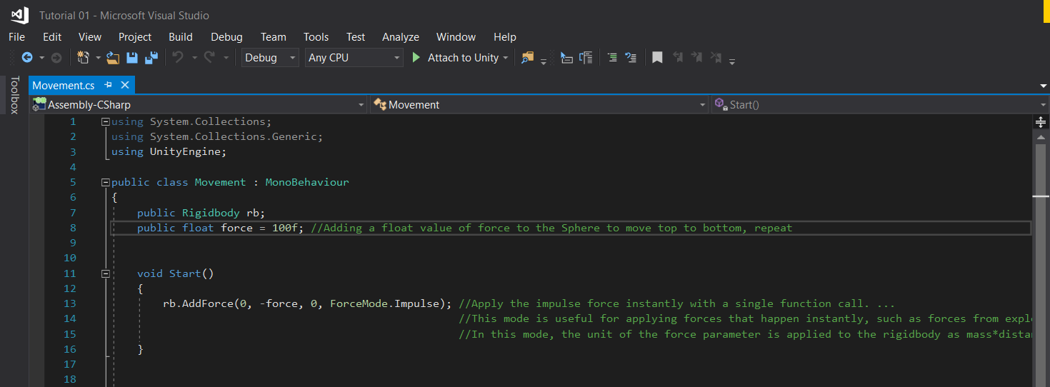

As you can see, I have added “public Rigidbody rb”. This means we have to add the Respective Rigidbody of the object as in our case the Sphere Rigidbody in Unity. Then the rest of the functions know which object that we are applying them to.

In the next line I have added a force to the Sphere to move from top to bottom. Since it is public you can adjust that in Unity as well.

***What is ForceMode.Impulse?***

Apply the **impulse** force instantly with a single function call. ... This mode is useful for applying forces that happen instantly, such as forces from explosions or collisions. In this mode, the unit of the force parameter is applied to the Rigidbody as mass*distance/time.

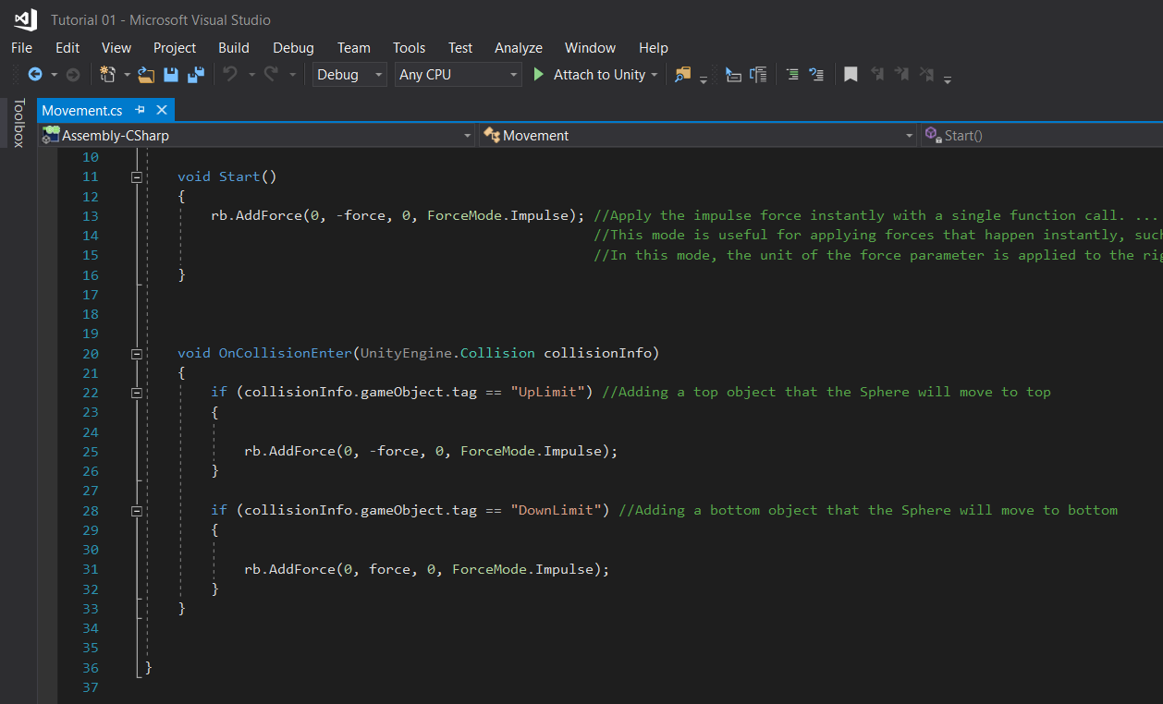

Now you will find out why we added to objects named Top and Bottom Stomps.

In the Script we will use void OnCollisionEnter function for this.

And I have added two “if” statements un this function. The first one is for moving up.

1. **If the GameObject(Sphere) Collide with UpLimit(TopStomp) move down(-Force)**
2. **If the GameObject(Sphere) Collide with DownLimit(BottomStomp) move Up(-Force)**

Repeat….

Still our project is not finished because we haven’t added the Rigidbody into the Script in unity, We haven’t tagged the Top and Bottom Stomps as UpLimit and DownLimit.

After you have done them, drag the Sphere object from the Hierarchy menu to Project section. And Now you have made a Sphere prefab. You can drag the Sphere prefab to the scene menu and make some number of Obstacles. And now you have made number of Obstacles or some kind of decorations to your game.

If the Spheres bouncing off the Ground and fall into the Unity Surface that meas the Gravity is still on. Therefore Untick the Gravity Under Rigidbody and Untick the Rotation (x,y,z) under Rigidbody > Constraints > Rotation

Enjoy!

Lakshitha Abeyrathna